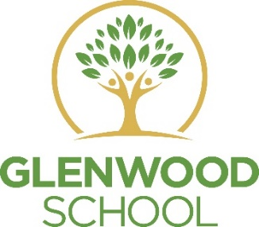
Glenwood School
Computing
As a subject, Computing is one of the most fundamentally cross curricular subject Computer science incorporates techniques and methods for solving problems and advancing knowledge, and includes a distinct way of thinking and working that sets it apart from other disciplines. The role of programming in computer science is similar to that of practical work in other sciences – it provides motivation and a context within which ideas are brought to life.

Communication and Advocacy

Pupils will be confident digital citizens who will have the knowledge, skills and understanding on how to use technology securely, creatively and effectively.

Independence and Preparing for Adulthood

Pupils will be encouraged to access Computing content independently of their level, this will promote high expectations and engagement and will also result in preparing them for the wider world.

Physical, Social and Emotional Good Health

Pupils will also understand how technology has changed the way people interact with their daily lives. social issues that can affect users of ICT, including the use and abuse of personal and private data. They will also Understand the main aspects of legislation in place example copyright and data protection act.

