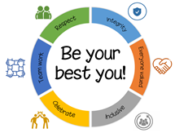
Glenwood School – Values in our Curriculum

Value | Where you will see it in my subject
Respect | - UK and British Values  - Human History Timeline  - Child Labour.
Integrity | - UK Democracy  - Slave Trade  - Child Labour
Team Work | - Talking tables (Group)  - Jigsaw maps  - Keyword search and snap.
Everyone Valued | - Pupil lead bingo  - Holocaust  - Development  - Child Labour
Celebrate | - Christianity and Hinduism Celebration  - Keyword Bingo  - Stamps and points
Inclusive | - UK and British Values  - Human History Timeline  - Holocaust

