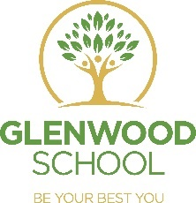
Class of 2021 – Exam Results

Congratulations to our hard-working Year 11s who so deserve their outstanding achievements.

Due to the impact of the COVID-19 pandemic, most exams and assessments did not take place in 2019/20 or 2020/21. As a result, the government announced it would not publish school results in Autumn 2020 or Autumn 2021.
Our pupils’ results were achieved on work completed, submitted and moderated as GCSE, Entry Levels and equivalent qualifications.

Outcomes:
There were 23 pupils in Year 11 – all of whom achieved a minimum of an Entry Level in English and Maths

6 pupils achieved a GCSE English Grade
5 pupils achieved a GCSE Geography Grade
21 pupils achieved an Entry Level Science Grade
20 pupils achieved an Entry Level ICT Grade
17 pupils achieved an Entry Level Pathways in Art
17 pupils achieved and Entry Level Pathways in PE
19 pupils achieved a BTEC in Home Cooking Skills

Every Year 11 is enrolled onto a college course. We wish them every success. Keep in touch!

